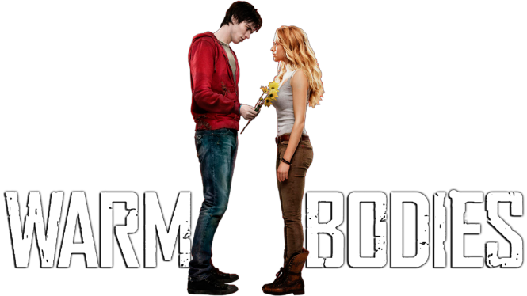
A Study in Apocalyptic Cultural Phenomena

Sociological Perspectives
Functionalist Perspective
According to Functionalists, societies are like biological systems in which unneeded parts eventually disappear. What are some aspects of society that might disappear if a zombie apocalypse were to occur? Why would they disappear?
Conflict Perspective
During a zombie apocalypse, how do the powerful survivors maintain their power over the less powerful survivors?
Symbolic Interactionist Perspective
How does the new culture of the zombie apocalypse influence how individuals interact with each other?

Norms
How are norms, guidelines for daily behavior, changed by the zombie apocalypse? Provide 3 NEW norms in the zombie apocalypse.

Culture of Zombies/Humans - choose 3 of the 5 below.
What are some norms of the culture of the zombies in Warm Bodies? (give me 3)

How does Julie conform to this culture? What kind of social control is this?

Deviance – Can we label R as a deviant? Why or why not?
Are there any other deviants in the zombie culture? How can you tell?

How does Perry, Julie’s bf, deviate from the pre-zombie apocalypse norms in his relationship with her?

